Note: This document outlines the Engineering Excellence team’s roadmap for SDE onboarding.
Doc Ninja Thoughts:
- What did the doc do well?
  - The document uses plain, global English and a simple writing style that is easy to understand.
  - The document uses data to clearly explain the scope of the program and its customers.
  - The tenets present tradeoffs to help the team make prioritization decisions (e.g. choosing topics based on what SDEs need, not what content partners want them to learn).
  - The document uses a clear problem, impact, lesson learned structure to highlight key misses over the past 12 months, with vocally self-critical analysis. The document also uses an easy-to-follow structure to outline likelihood and mitigation plans for major risks.
- Where could the doc develop further?
  - The document can develop a clearer purpose statement at the top of the document. We know what is out of scope, but what does the author want from the reader - approval for the SDE onboarding roadmap?
  - The Appendix takes up 15+ pages in the document, which will be difficult for readers to absorb. The author can consider streamlining the Appendix to the most important information needed.
  - The document is missing next steps at the end.

This document covers the onboarding of SDEs. All other job families are out of scope and will be addressed separately; this includes SDMs, and all other tech ICs.

PROGRAM DESCRIPTION
Today, Software Development Engineer (SDE) Onboarding consists of two parts: attending the 1.5 day in-person Bootcamp and completing SDE 101, the 12-week self-paced program. The SDE Bootcamp, launched in 2012, reduces the time it takes new engineers to start innovating using Amazon’s software development technologies by an average of 5.63 weeks to first commit (see full ramp up savings in Appendix A). In addition, we provide onboarding for SDE Interns, available during hiring peaks in January, May and June.

The SDE Bootcamp is available today from six regional hubs in North America, Europe and India (see Appendix B for full bootcamp metrics by hub), providing in-person training to 6,094 (94%) new SDEs in 2016 (see Appendix C for SDE hiring by country). Bootcamp educates new SDEs on Amazon’s software architecture evolution, developer culture, information security, legal, and Open Source policies. During the labs, new engineers gain practical hands-on experience using Amazon's Builder Tools, working through the full software development cycle.

SDE 101, introduced in April 2015, provides on-going learning for new SDEs covering 12 need-to-know topics, selected by managers and engineers. SDE 101 was created to address the diverse quality of onboarding across the thousands of engineering teams. The 101 training delivers needed information without bloating Bootcamp. In 2016, 74% (4,945) of new SDEs accessed SDE 101, and 1,910 SDEs have completed the program to date (2,075 completions from all job families). This is currently a one-size fits all program for all SDEs joining, regardless of previous experience or level of understanding. Appendix G highlights a full list of modules and content partners.

MISSION
EE will ensure all SDEs have access to the best introduction to Amazon and our development culture.

VISION FOR YOUR SPACE
All new SDEs joining Amazon will receive the right training, at the right time, on the technology they will use. Our customers will learn about the topics they need to get started, understanding Amazon’s culture, the technology they will use, and other common tools they need. Our newest engineers will be able to access EE’s standard learning track and have options to add other modules and topics they feel are more relevant for them and their team throughout their onboarding.

New SDEs will gain the skills to know where to go to learn more, have access to resources to refresh their memory so they don’t have to remember everything on day one, and have options to ask for help from people who can help them immediately. Training will no longer focus on teaching a new SDE everything in their first week, but work to understand when to introduce new topics for immediate application and knowledge retention. This will allow engineers anywhere in the world to learn and grow their skills and access the experts in a way they feel most comfortable.

Learning will be pushed to new SDEs throughout their onboarding. For example, on-call training will be made available when they are added to the rotation and include simulations to create a scenario that mimics real-life as closely as possible. Managers will be actively involved in onboarding, with the ability to track progress and understand areas where an engineer may need further support and guidance. A new engineer’s learning plan can be supplemented to incorporate team-specific topics. Managers will also be advised on best practices around pre-onboarding, so new engineers feel welcome and get off to the best start with their new team.

TEAM TENETS
- We choose our topics based what our SDEs need, not what our content partners want them to learn.
- We don’t just tell SDEs the what, we also tell them they why.
- We prioritize training on tools and technologies common across multiple teams.
- We don’t confuse breadth of content with effectiveness. If we can make content more effective by being shorter and easier to consume, we will.
- Our customers aren’t homogenous. Our training will provide different paths for different needs.
- Our training is easily adaptable to updates to tools and processes.
- Our content changes as tools and processes change.
- We hold content partners accountable for the accuracy and relevance of their training through formalized partnership agreements.

KEY CUSTOMERS
Customer | Point of Contact | 2017 SDE NEW HIRES  (total est. 16,223) | % of total
SDE Interns | University Recruiting (UR) for N.America & India. Unknown for rest of World | 5,000 | 31%
SDE: returning interns | As above. | 1,000 (50% rehire rate) | 6%
SDE: College Hires | No common POC | 4,610 | 28%
SDE: Industry Hires | No common POC | 5,613 | 35%
SDEs with no access to training hub | No common POC | 973 | 6%
SDEs joining everywhere else | No common POC | 15,520 | 94%

Full time Bootcamp attendance continues to increase; from 3,829 in 2015 to 6,094 in 2016 (59% increase) and 2017 Q1 attendance is up 68% compared with Q1 2016 (2,453 attendees). This attendance represents 93% of primary customers targeted to attend SDE Bootcamp, but this number reflects total attendance from all engineering job families.

Attendance at Bootcamp is open to anyone that wishes to attend and for job families, in part because there is no other Builder Tools training available. Whilst the training is currently open to all other engineering families, we don’t optimize the experience for them.

Online labs are available to SDEs who cannot access bootcamp at our existing hubs. Last year this totaled 348 SDEs (6%) of all SDEs hired. However, these labs were used 8,806 times, by other job families and SDEs looking to practice and build their skills after bootcamp (see Appendix C for the full usage of the BT online labs and survey data responses).

In addition to full time SDE hires, EE provides training for the growing number of SDE Interns joining Amazon. 1,998 attended the SDE Intern Bootcamp in 2016, with a global forecast projection of 3,500 in 2017. 45% of these interns will return in May 2017 as SDE 1 hires. SDE Intern Bootcamp is only available during peak onboarding periods in January, May and June. 732 returning interns (41% of 2016 summer Seattle interns) will be re-joining Amazon as full time SDEs from May. (See Appendix F for the full 2016 retrospective of changes and learning outcomes).

KEY MISSES OVER THE PAST 12 MONTHS

- Content not revised to meet changing customer needs
PROBLEM: Previously, EE PMs were required to balance managing the Bootcamp operations in addition to developing the content. As a result, only minor updates to existing labs and presentation decks were made, resulting in the Bootcamp content being largely unchanged since its launch. Similar feedback themes are still prevalent today; desktop set-up is hard, the labs don’t go into the “whys” around the tools, and there is so much content covered that it is hard to remember it all and apply what you’ve learned. The 101 content has also remained relatively static from the content launched in April 2015. In total across all 101 modules and Bootcamp, 611 SIMs have been raised to EE around this content, with common threads around broken links in the e-learning for OE Bronze and Oncall 101, as well as varying video quality. 255 remain open, with 17 relating to broken links in oncall training and 11 for deprecated assets referenced in OE Bronze.

IMPACT: Amazon’s SDEs have been changing in terms of the technologies they work on. When the Bootcamp was first established, over 85% of SDEs were developing web services. Now, 31% are focusing primarily on mobile development according to 2016 tech survey (appendix E), and a Steam goal is set to move all new development to Native AWS as default.

LESSON LEARNED: We need dedicated resource to maintain the content and build new learning resources based on business changes, as well as understanding how our customers and their needs are changing.

- Scaling challenges of current model
PROBLEM: Continued growth of SDE hiring is putting huge strain on the current Bootcamp model and PM resourcing, and population growth outside our current hubs continues. The current Bootcamp model relies on a minimum of six trainers per session, with multiple sessions being run in Seattle each week to keep up with demand. To scale this into new locations, a lengthy train the trainer (TTT) process must be completed, with a minimum of 12 trainers for the initial launch (growing to around 30 to sustain a bi-weekly cadence). In addition to this, little investment has been made into providing quality technical onboarding for new SDEs unable to attend the in-person training, and the existing online labs were due for deprecation in 2016.

There is additional pressure from other job families attending the SDE Bootcamp to learn the basics of using Builder Tools. This is in part due to the fact that there is currently no other training available, and secondly that EE has always allowed other job families to attend, despite feedback from that the content is not wholly relevant and is too technical for them.

IMPACT: At the current rate of growth, EE is finding it challenging to find the resource to support the Bootcamp in its current format, from both a PM and trainer perspective. More PM resources have been added in each region to provide dedicated support, but it takes between 0.3 and 0.5 PMs to run this program in each location weekly. The scaling challenges are putting additional strain on the Bootcamp PMs, as they struggle to find rooms to accommodate the growing class sizes, often running multiple sessions in the same locale. Sustaining the Senpai (trainer) pool is a growing pain point for EE.

LESSON LEARNED: In 2016, the operational burden of running SDE Bootcamp was reduced by 17 hours per session. However, to scale more effectively a simplified trainer model must be adopted, with more flexible structures and commitments, and fewer trainers required. Blended or online resources must be established to reduce inconsistency of delivery and reduce time taken for new trainers to be ramped up. Blended learning has been proven to increase knowledge retention as resources can be accessed as needed (as seen in the 2016 Intern Bootcamp).

EE must radically change the structure and content covered in Bootcamp to keep up with changing customer needs and reduce the operational burden in running this program. This training should focus on building a breadth of understanding on essential week one topics rather than focusing solely on building muscle memory around the use of builder tools.

KEY ACCOMPLISHMENTS OVER THE PAST 12 MONTHS

- Segmented, more scalable Intern Bootcamp experience
In 2016, the SDE Intern Bootcamp was re-vamped, based on feedback received from interns and managers relating to cognitive overload and lack of knowledge retention, in addition to an escalating scaling problem, which saw the number of interns grow from 1,504 in 2015 to 1,998 in 2016, to an estimated 3,500 in 2017. The new blended program focused the learning for SDE interns on the key areas required to succeed during their internships, and provided short and concise videos (3-10 minutes long) on key operations an SDE must do (e.g. making a code change, pushing code, submitting for code review) in addition to a self-paced classroom session where interns completed the labs under guidance from experienced SDEs. Total classroom time for new SDE Interns dropped from 6.5 hours in 2015 to 3.5 hours in 2016.

A total of 29 sessions were held during peak intern onboarding (between May and July) in four hub locations; Seattle, Hyderabad, Bangalore and Toronto. Managers and interns praised the redesigned program: “I just want to thank the team for creating such great quality videos that really helped me grasp the high level concepts behind the builder tools.” The videos were played 13,747 times during this period and have since been incorporated into the Builder Tools training for engineers who have no access to a current SDE Bootcamp hub. In addition to this, the operations load on the EE team was dramatically reduced as a result of the blended program, reducing total ops time from 156 hours (or 4 weeks) in 2015, to 72 hours in 2016 (54% reduction) despite the increase in number of interns onboarded. Content scores remained consistent with the previous years; 4.21 in 2016 compared with 4.29 in 2015, and the full time Bootcamp scored an average of 4.20 out of 5.

- Scaled onboarding program to support continued growth of SDE population served
The SDE population continues to grow YoY, from a global Bootcamp attendance of 3,829 in 2015, 6,094 in 2016 (59% growth) and a trending YoY growth of 68% on 2017 based on Q1 figures (2,453 in Q1 2017 v 1,460 in Q1 2015). The EE team has managed to scale the existing program throughout 2016, and maintain consistent scores in terms of content and presenter quality, despite the audience doubling in size between 2015 and 2016. New hub locations were added in San Francisco for the Bay Area and in Bangalore, to meet the growing hiring numbers in India.

In June 2016, EE began segmenting out other engineering job families who still wanted to attend the SDE Bootcamp to track feedback and attendance data more accurately by job family. This provided training for over 550 engineers outside the SDE job family, and enabled EE to establish feedback trends for these jobs families. The top three job families by attendance were SDM (17%), TPM (14%) and Support Engineers (13%). Consistent feedback was that the training was too technical in nature and specifically targeted at SDEs. This is an area that will be addressed via a program outside this onboarding paper and work is currently underway with the TPM Samurai to develop an alternative learning track for non-developers. EE also piloted a new SDM Bootcamp program in Q4 2016.

MAJOR INITIATIVES OVER THE NEXT 12 MONTHS

- Redesign of SDE Onboarding program to reflect today’s SDEs needs
The current SDE Bootcamp is outdated, and doesn’t deliver the training needed by our current and future SDE hires. The current Builder Tools training teaches the full development cycle for Prod developers. Amazon is changing, with more mobile developers joining, and more teams migrating to Native AWS. We need to adjust the training from the current format. In order to understand the exact requirements to best serve our customers we will conduct undertake a number of experiments to finalize the planned approach by Aug 2017. This will be owned by Craig Plain.

- Find more scalable ways to train SDEs
EE will experiment with existing learning platforms available across Amazon to understand customer behaviors, learning preferences and access more comprehensive completion metrics. The current 101 structure has allowed EE to have ongoing interactions with new engineers throughout their first 12 weeks at Amazon, teaching them about other important topics critical to being a successful SDE. But the current use of email and wiki is rigid in its structure, pushing new content out once a week, with no option for engineers and their teams to edit learning paths or prioritise focus on the topics that are most important to them. In our current structure, we assume learners want to learn about just one topic each week, rather than having the flexibility to learn at their own pace. There is little opportunity for learners to test what they have learned or understand the areas they may need to spend more time learning about to apply and advance their skills in real-world scenarios.

By conducting experiments on KNet, Kiku and other platforms, we better understand the preferred learning styles, monitor changes in content adoption, and gain access to more reliable metrics. Experiments to understand click-through rates will give us more accurate adoption and usage data. In addition, more e-learning objects will be created to understand usage, knowledge retention and understanding through tests and activities.

Experiments will start from July 2017, and feedback and data used to influence the re-design plans from August 2017. This will be owned by Craig Plain.

PROGRAM GOALS
Goal Name | Description | Completion Date | Current Status
Determine segmentation of SDEs | Develop a way to segment customers to filter them onto the right track for onboarding based on where they are coming from and their team technology choice. | June 2017 | WIP
SDE Intern Bootcamp quality maintenance | Maintain quality of SDE Intern Bootcamp in readiness for the Spring/Summer peak onboarding season, achieving content score of 4.20. Ensure the labs are robust to scale as needed. | June 2017 | Work complete (awaiting quality scores)
Develop new bootcamp experience | Complete analysis and design phases for the new onboarding experience to fully understand content to be included and modality for scalable solution. Conduct pilots of new program and present redesign for global roll out. | August 2017 | Not started

MAJOR RISKS OVER THE NEXT 12 MONTHS

1. Change from the norm/lack of business support for new onboarding program
SDE Bootcamp is an established and trusted program. The major risk is that by changing the program teams may feel the benefit gained is diminished, will no longer send their new engineers to the Bootcamp or look to imitate locally. In addition, with a move to more online and self-paced learning, there is a risk around continued engagement with the program as new SDEs become more embedded with their team and their productivity is increased. Amazon is an extremely fragmented organization and pushing organizational change around training completion is likely to be ineffective without strong results to highlight the success and positive impact.

Likelihood: We rate this risk as “possible”.
Mitigation Plan: Clear pilot programs, with tracked outcomes, with a focus on gathering both quantitative and qualitative data to support any changes that are rolled out at a global level. We will communicate clearly to all those impacted to emphasise the benefit of changes made.

2. No confirmed commitment from Builder Tools
Builder Tools training is a key element to SDE onboarding and currently takes up the full day 2 content. The labs used at focused on Prod development, teaching a new SDE the full development cycle. These labs are currently owned by EE Dev as a result of legacy decision making. In order to replicate the real-life development experience of Amazon’s newest SDEs and teach the topics they need to know, labs will need to be rebuilt to focus on the need to know aspects, as well as the changes resulting from the migration to Native AWS.

Likelihood: We rate this risk as “possible” that we will fail to secure resourced from Builder Tools.

Mitigation Plan: We have an open OP1 ask with Builder Tools to secure the needed resources to build new labs and secure support to maintain these and the supporting documentation.

- Existing LMS not suited to flexible learning
Amazon’s current LMS does not support the learning experience we are looking to create for new SDEs. KNet will not allow for flexible learning tracks, and users complain of the clunky nature of using this to access learning materials and e-learning. In addition, EE doesn’t have instructional design resource to create and update e-learning resources.

Likelihood: We rate this risk as “highly likely” that we will fail to find a way of creating the designed scalable learning plan.

Mitigation Plan: We will look at alternatives to KNet, including both in-house options and what it would take to build the desired platform. More research will be conducted to look at currently options available on the market.

- No resource to build new platform
Outside of the SDE Bootcamp, all other learning related to SDE onboarding is based on wiki and promoted to SDEs via email. This model lacks the flexibility to build truly self-paced, scalable learning that meets the customer’s needs. It lacks options for learners to “build their own track” and content remains static and disconnected as a new SDE progresses through the program. In order to create the desired learning our customers need, it is likely a system will need to be built that allows tailored learning tracks to be designed, as well as providing needed metrics and data to understand the user experience and usage. Presently, there is no resource available to build this out.

Likelihood: We rate this risk as “highly likely” that we will fail to find resources to build this in 2017.

Mitigation Plan: We need to rethink the way we use online learning to supplement the existing in-room experience, potentially building the solution from scratch. Experiments using existing online platform will help us understand user behavior to help us scope the longer-term desired system. Requests will need to be made to EE Dev to understand if this is something they can support in 2017/2018.

5. Scaling of program outside established training hubs
Onboarding effectives increased when there is a human interface to it. The current model provides training for 94% of new SDEs joining Amazon; this leaves hundreds unable to attend this training due to travel and other restrictions. In order for EE to fulfil its objective of providing an excellent experience, regardless of start location, the new program must be easier to scale in smaller and more remote development centers or EE must adopt a new strategy emphasizing the importance of attending this training for all.

Likelihood: We rate this risk as “likely”.
Mitigation Plan: Conduct customer interviews with teams currently not serviced by Bootcamp hubs to understand local onboarding structures and experiment with lighter-weight structures for knowledge transfer with smaller classes.

APPENDIX A: Training Metrics for SDE Bootcamp

The training is evaluated in two primary ways: ramp up metrics (time to first code commit & personal stride*), and customer surveys per session.
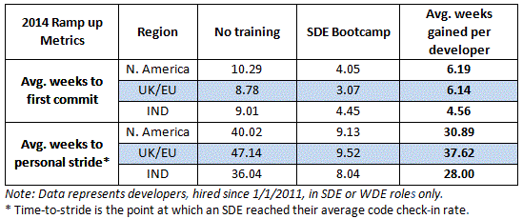
Since the program launched in Seattle in the summer of 2012, it has served thousands of engineers and earned an average audience score of 4.43 (out of 5) for quality. On average, teams spend 6.75 hours per new SDE training them on the basics of the Amazon developer toolset, the hands-on session centralizes these training efforts, returning valuable time to teams. Here’s what our customers are saying:
“Our new hire was able to get his development workspace setup with almost no assistance, and was immediately able to use Brazil tools and Apollo, and write code to make a service call. He was able to get a small production change out in his first week, which is an improvement over what we have seen with other new hires.” Mark Piper, SDM, Kindle Education Tech
“The big difference is that we spend less time answering general amazon questions and more time answering questions specific to what our team does.” Christina Beatty, SDM, Tech Venenzia

** Please note: time to stride metrics are no longer gathered due to the expense in time and resource to capture and analyze these numbers.

APPENDIX B: Bootcamp hub locations
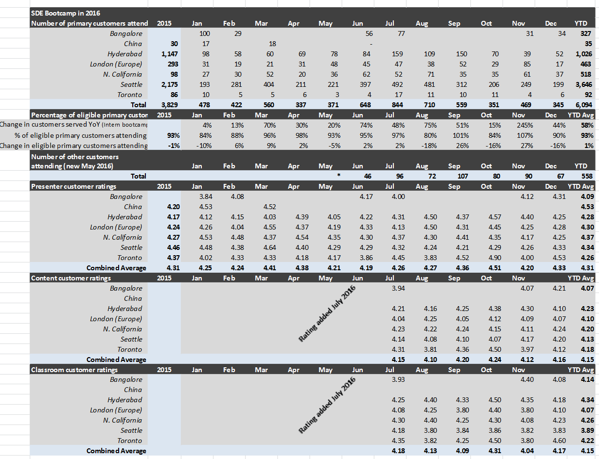

APPENDIX C: Onboarding data (total:no hub:location)
Table 1: Onboarding numbers by country
(orange highlights are those currently not served by a bootcamp hub)

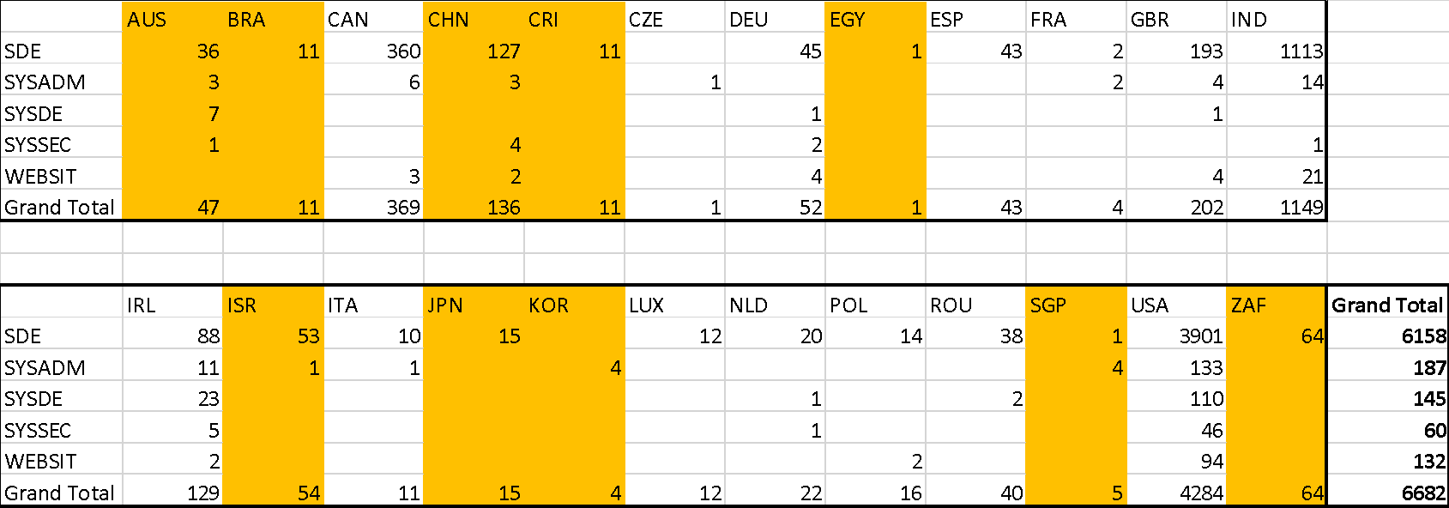

TOTALS:
Hub | 6334 (94.8%)
No-hub | 348 (5.2%)

Table 2: Onboarding breakdown by job level

Job Family | 04 | 05 | 06 | 07 | 08 | Grand Total
SDE | 3139 | 2042 | 783 | 160 | 34 | 6158
SYSADM | 92 | 61 | 26 | 1 |  | 187
SYSDE | 46 | 75 | 22 | 2 |  | 145
SYSSEC | 26 | 15 | 15 | 3 | 1 | 60
WEBSIT | 76 | 54 | 2 |  |  | 132
Grand Total | 3379 | 2247 | 848 | 166 | 35 | 6682

APPENDIX D: Online (BT) Labs usage and survey data

EE Online Labs Survey: November 2016

1. I was able to complete one or more of the online BT labs (choose one)
120 Yes
5 No
2. If you answered “No” to the previous question, please tell us why (select all that apply): (select all that apply)
0 I inadvertently accessed these labs (if you choose this selection, you can now EXIT the survey)
2 The labs did not work for me (ran into bugs, did not perform as expected, etc.)
3 The instructions were inaccurate and/or outdated
0 The instructions and workflow were hard to follow
1 The labs took too long to complete
0 The labs were not relevant to me and/or my work
1 Other
36 N/A - I completed one or more of the labs
3. What is your role at Amazon? (choose one)
101 SDE/T
0 Application Engineer
1 Business Intelligence Engineer
2 Data Engineer
0 Network Dev Engineer
1 Network Engineer
3 Quality Assurance Engineer
0 Security Engineer
2 Support Engineer
1 Systems Engineer
3 Web Dev Engineer
0 Machine Learning Scientist
1 Programmer Analyst
0 Research Scientist
1 TPM
5 SDM
4 Other

4. How long have you worked at Amazon (as full-time employee)? (choose one)
0 I prefer not to disclose
95 0-3 months
18 3-6 months
1 6-12 months
8 1-3 years
0 3-5 years
1 5-10 years
0 10+ years
5. Were you aware that Engineering Excellence offers an in-person Builder Tools 101 course prior to working on these labs? (choose one)
89 Yes
34 No
6. Did you take the in-person Builder Tools 101 course prior to working on these labs? (choose one)
37 Yes
87 No
7. What is/was your PRIMARY motivator for choosing to work on these labs? (select one) (choose one)
27 I am looking for additional opportunities to practice the tools/skills I learned in the in-person Builder Tools 101 course (ex. creating a package, making a code change, bug fixing, etc.)
33 I am looking for a hands-on introduction to Amazon’s Builder Tools and prefer online/self-paced learning
5 I am looking for a hands-on introduction to Amazon’s Builder Tools and need something shorter and lighter than provided within the in-person Builder Tool 101 course
7 I am looking for a hands-on introduction to Amazon’s Builder Tools and this was the only training content I could find
27 I am looking for a hands-on introduction to Amazon’s Builder Tools and don’t have access to the in-person Builder Tools 101 course based on my location
2 I am looking for more intermediate or advanced training on Amazon’s Builder Tools
17 I want to complete Amazon SDE 101 and get my phone tool icon!
7 Other
8. The labs satisfied the learning need identified in question #7 above (choose one)
10 Strongly disagree
8 Disagree
11 Neither agree or disagree
77 Agree
19 Strongly agree
9. If you “disagree” or “strongly disagree” with the previous question, please tell us why (select all that apply): (select all that apply)
3 The labs were too easy—I was looking for more advanced training on Amazon’s Builder Tools
0 The labs were too difficult—I was looking for more of a basic overview on Amazon’s Builder Tools
11 The labs did not provide enough context around the “what” and “why”; I felt like I was just following instructions
5 The labs did not cover the stages of the development process I was looking for
5 The labs did not cover the specific tools and/or concepts I was looking for
1 The labs were not relevant to my team’s development process
7 The labs did not work well for me (ran into bugs, did not perform as expected, etc.)
0 Other
34 N/A - the labs satisfied the learning need identified in question #7 above
10. If new hands-on labs were offered, which of the following experiences would be MOST valuable to you (select one): (choose one)
55 I’m new to using Amazon’s Builder Tools; give me opportunities to practice basic skills (ex. creating a package, making a code change, using Pipelines, bug fixing, etc.)
31 I already know the basics; give me an opportunity to dive deeper and practice more advanced skills using Amazon’s Builder Tools (please provide these specific topics in the “Other” box below)
37 I want to learn more about Native AWS; give me an opportunity to practice deploying software to native EC2 instances using Pipelines and CodeDeploy
1 Other (provide specific topics below)

APPENDIX E: Tech Survey – types of developers

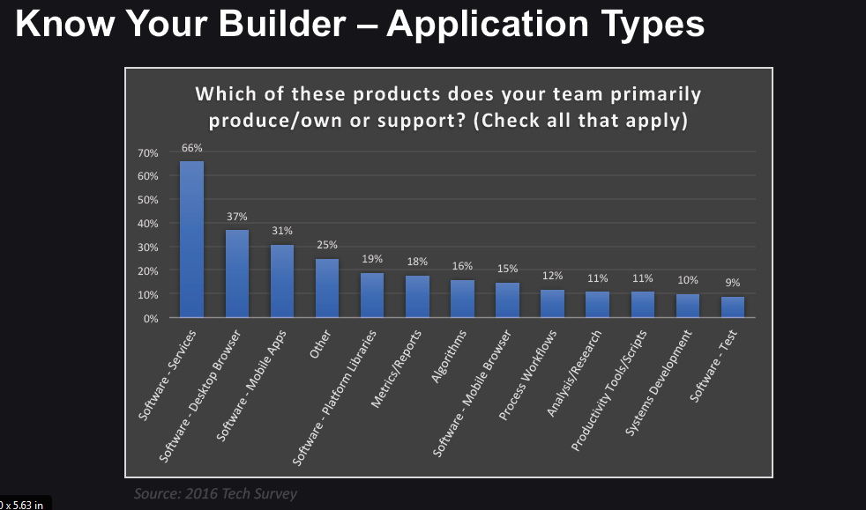

APPENDIX F: 2016 SDE INTERN TECHNICAL ONBOARDING SUMMATIVE

This document aims to outline the changes, and successes and future opportunities for the SDE Intern onboarding experience to Amazon globally, following a programmatic redesign which took place over a 12 week period from February 8th. The new SDE Intern Bootcamp launched on May 2nd, when the first SDE Interns joined in India, Seattle and Toronto.

Problem Statement
In 2015, SDE Intern 101 and a revised SDE Intern Bootcamp were launched to resolved key customer pain-points. These pain points include a lack of standardized technical onboarding and “drinking from the fire hose” – associated with the pace and volume of information Interns need to retain in order to complete their internship, as well as scaling challenges for EE with the growing numbers of Interns joining, especially in North America. There was a lack of global consistency in Intern onboarding across the various regions, resulting in some receiving no training.
The revised SDE Intern Bootcamp was an abridged version of the SDE Bootcamp offered to full time engineer hires, with “What it means to be an SDE” delivered during NHO (new hire orientation), and Information Security and Builder Tools condensed into a single day of training, lasting 6 hours.
SDE Interns told us that they felt overwhelmed with the volume of learning in the single day, and the need to commit the workflows to memory following the in-person training. Interns cited a lack of flexibility in how they learn an issue; switching back and forth between lecture and guided labs doesn’t work for them and they want more opportunity for independent, self-directed learning. The program was difficult to scale, and required a dedicated resource to roll-out, with many manual processes and a heavy commitment from trainers required during the 8-week onboarding period.
As an SDE Intern at Amazon
- I want to be get ramped up on Amazon’s developer toolset quickly
- I want to learn about the tools I need to complete my Internship
- I don’t want to feel overwhelmed with information I won’t use
- I don’t want to be a burden to my team
As an Intern Mentor
- I want to support my Intern deliver their project effectively
- I want to spend my time teaching how our team users the tools, not the basics
- I want to feel like my time is adding value to my Intern, the team, and our projects
See Appendix 1 for more detailed User Stories.
Program Summary
Program Goals
- Tailor Builder Tools in-person training to focus on practical application, reducing cognitive overload
- Provide Interns with a blended learning experience
- Roll out new training in Seattle, Hyderabad and Bangalore (where large cohorts of Interns are joining)
- Achieve 95% training participation of Interns hired in the above locations
- Reduce EE PM operational load by 50%

2016 Changes
Instead of Interns attending 6.5 hours of lecture combined with labs, this year, the lecture portion was delivered via seven self-paced video tutorials (~10-15 min each) produced by Engineering Excellence in partnership with Builder Tools and Day 1 Media. Builder Tools for Interns made up week 1 of SDE Intern 101. After watching the videos on their own time, Interns were invited to attend a 3-hour classroom session, to apply the concepts they learned in the videos through a series of hands-on labs. The classroom sessions were facilitated by our certified Builder Tools Senpai (trainers) and Engineering Excellence.
The content of the Bootcamp was designed to focus on the need-to-know topics and best practices Interns need in order to successfully complete their projects.
The Engineering Excellence Dev team built a customized Octane workflow template that automatically creates/deploys the ES2 service to Apollo environments and creates a Pipeline that significantly reduced the time required to set up the service for Interns. (See more in The Highlights section below).
Roll-out
The ability to scale globally was a key success factor. As Amazon’s developer population grow world-wide, this program had to be able to scale effectively up and down, depending on the initial size of the site. For 2016, the program was piloted in four locations; Seattle and Hyderabad (where EE has PMs in situ), as well as Toronto and Bangalore (no PM present). These sites were selected due to their differing number of Interns joining; smallest intake 7 in Toronto to largest of 317 in Seattle. The total number of Interns over the 8 week period from 2 May to 21 June was 1,998.
The changes to the Builder Tools classroom session reduced Senpai and TA (teaching assistant) commitment by around 100 developer hours.
The Highlights
Primary Customers Served
Between May 1st and July 29th 2016, 1,998 SDE Interns in North America and India (101%) participated in the SDE Intern Bootcamp (see Appendix 4 for a more detailed breakdown). This exceeded the goal set of 95% Interns hired to attend the Bootcamp training.
- Seattle – 1,803 (102% of 1771 joined)
- Hyderabad – 90 (86% of 105 joined)
- Bangalore – 67 (104% of 64 joined)
- Toronto – 38 (100% of 38 joined)
A total of 29 Intern Bootcamp sessions were coordinated across the four regions (18 in Seattle, 3 in Bangalore, 4 in Hyderabad and 4 in Toronto). 89 people actively supported the Bootcamps, including 76 Senpai and TAs, 11 EE PMs and Greeters, and 1 video host.
Intern intake peaked at 406 in the week commencing 16 May. 6 Bootcamp sessions were run in 3 locations, teaching 392 Interns (98% of Interns hired).
ES2 Service redesign
The Engineering Excellence Dev team built a customized Octane workflow template that automatically creates/deploys the ES2 service to Apollo environments and creates a Pipeline. This template allowed Interns to skip the manual configuration steps found in the standard BT101 training and focus their learning on the most relevant labs for this audience (Making a Code Change and Bug Fixing) – see appendix 3 for more details. This saved on average 2 hours of build time per Intern attending Bootcamp.
New Video Tutorials
The videos were well received and were rated at 4.12 out of 5 for training effectiveness. Interns praised the new video format for Builder Tools liking their quality and simplicity in which they introduced them to Amazon’s toolset. Senpai reported that the Interns had a much better understanding of the key concepts, removing some of the more common classroom blockers they had seen in previous years. 98% of Interns watched the videos before attending the hands-on Bootcamp, praising their clarity and high quality of production.
The tutorial videos were watched a total of 13,747 times by 2,604 unique viewers (2,041 SDE Interns), from 14 countries, including US, India, China, Japan, South Africa and Romania.
Anecdotal comments from Interns included;
I enjoyed the videos they provided a bit more than the actual bootcamp but it was still very helpful. I could tell what we were learning would actually be used often during the duration of our internships.
The tutorials were very clear and easily understandable. It was very helpful to have watched the tutorials before attending. It might help to add some more detailed information about the pipeline, specifically the steps that we did for the pipeline during the Bootcamp. My team members and I did not fully understand what was happening during the pipeline online tutorial.
I just want to thank the team for creating such great quality videos that really helped me grasp the high level concepts behind the builder tools. I am an SDE Intern who was also an SDE Intern 2 years ago. Back then, even on the last day of my internship I didn't fully understand the builder tools I had been using for 3 months... Any time I had to dig through Apollo to do something I was always intimidated and lost, resorting to asking my mentor for guidance. These videos really helped solidify what parts of the builder tools do what, and how to use them together. Thanks!!
Operations
Interns were asked to self-register for their preferred Intern Bootcamp session via KNet. KNet registration was widely adopted and resulted in greater choice for Interns around their preferred session to attend. Operational load was reduced by 2 hours per session for the regional EE PMs who had previously had to manually collate joining data from HR systems and manually register and invite Interns, as well as respond to individual requests to move sessions.
Overall, in India, operations accounted for 3 hours per session; 1.5 hours managing the setup, including room booking and Senpai scheduling and 1.5 hours on the day support, setting up the session, collecting attendance and managing room logistics. This is in comparison to over 20 hours spent per session in 2015, which included a PM supporting the full 2 day (16 hours) bootcamp in person. This equates to an 85% reduction in time spent on operations and logistics.
“In 2015, in India, we followed the traditional SDE Bootcamp classroom model for Interns, who are our biggest customer base by volume. I felt very strained and felt that my overall enthusiasm and motivation to run the SDE bootcamp dipped because of the unsustainable operational burden. In contrast, as a result of the innovations and simplifications made to the Intern Bootcamp this year, the regional Bootcamp PM in India seemed in control and relaxed during the campus season,” quote from EE India PM, Ranjana Gopal.

In 2015, it took an estimated 156 hours (or 4 weeks) to organize the Intern Bootcamps in Seattle alone. Based on reports from the PMs in Seattle, this was greatly reduced to around 72 hours. This is still a significant number of hours to coordinate and ensure the intern experience was high. However, this equates to a reduction of 54% against the goal of 50% ops load reduction.
Overall, the PM experience was greatly improved compared to 2015, as manual actions were reduced substantially, and centralized communications sent to interns and managers based on auto-updating email lists (used as part of SDE Intern 101). And fewer Senpai were required to deliver the training, reducing the operations around scheduling and recruiting of a large enough pool of trainers to support.
The new training model also reduced the number of Senpai trainers required, and subsequently reduced the logistical time spent recruiting, training and scheduling these sessions. The classroom facilitation at the Intern bootcamps was shared amongst five EE PMs, spreading the workload over a pool of PMs rather than sitting with just one. This also ensured the knowledge was shared amongst more, eliminating the single point of failure which had existed in previous years, and reducing the cognitive overload for that single PM.
Finally, the reduction in classroom time, meant that there was no need to provide lunch to the 1,998 Interns joining. Providing only light snacks and refreshments, resulted in an estimated saving of $10k. (2015 spend c.$13/person on box lunches for Intern Bootcamp in Seattle, amounting to $17k total catering spend.) There was just one comment relating to food, from a session that ran through the lunch break;
“My Bootcamp (10:15-2:30), took place during lunch time, but no food was provided”.
Removing the provision of lunch was one of the risk outlined in the pre-mortem discussion, but the risk was not realized.
Participant Feedback Scores
SDE Interns were asked to evaluate the effectiveness of the training they received after they completed the SDE Intern Bootcamp. The program received an overall score of 4.22 on scale of 1 to 5 where 1 indicates “Need Improvement” and 5 indicates “Excellent”. 922 Interns provided feedback on the Bootcamp and the breakdown of the sections was as follows;
  - Video effectiveness = 4.12
  - BT Content clarity = 4.19
  - Instructor knowledge = 4.37
  - Instructor engagement = 4.18
The overall rating for Intern Bootcamp was 4.22, compared to 4.29 in 2015 (please note this is for Seattle only). As the format and delivery of the Intern training was so different to the 2015 program, a new baseline has been drawn at 4.22 for comparison with future years.
See Appendix 5 for more detailed and anecdotal feedback.
Program Communications
Stakeholders were provided information throughout the program development, including University Recruiting, Hiring Managers, Senpai and regional EE PMs. All Hiring Managers received a targeted email before they welcomed their SDE Intern to their team, explaining the changes to the program and actions required (appendix 6). This was listed as a lowlight in the 2015 summative review and a recommendation for the 2016, which was addressed. There were less than 20 managers who contacted EE for clarification on Intern technical training, with around 50% of those from managers based in other North American sites outside Seattle recruiting remit (including A9 and Kindle).
The Lowlights
Octane Outage
During the majority of Bootcamp sessions, issues with Octane hampered the initial package build at the majority of Seattle Bootcamp sessions. The large class sizes in Seattle Bootcamp sessions resulted in Octane performance issues, which could not handle the high volume of service calls. To mitigate, Bootcamp PMs had to stagger the start of service creation steps within the lab portion of Bootcamp, resulting in significant wait time during the session. Whilst there was documentation with guidance relating to action to be taken in the event of an outage, it was not easy to find or consolidated in one place, which would have made it simple for Senpai and PMs to take the necessary action. Despite the problems with Octane, Interns told us that they found it useful to watch real-time technical troubleshooting and found real value in working in a real-world Amazon environment.
You can read the full COE here: https://coe.amazon.com/coes/63733
In order for the SDE Interns to access the labs they required permissions through BT Manager. The process of adding students to the permissions group is entirely manual and can take up to 1 hour per regional intake due to the limitations of the system. And due to the nature of when new hire alias’ are created this activity could not be completed until after the new hire was already active at Amazon. This required the local PM to manually add each cohort before each bootcamp, which could take up to 30 minutes per session. Some Interns were not added to the roster, as a result of unknown alias’ or not accounted for on the Actuate reports. These Interns had to be manually added by the in-room PM, resulting in a negative customer experience and delay in set up.
North California Recruiting Disparity
A disconnect between the multiple recruiting teams hiring Interns in the Northern California region, resulted in an inconsistent onboarding experience. Some managers expected a local version, but a central decision was made by the University Recruiting (UR) team based in Seattle for a centralised experience in Seattle. During the Intern onboarding period we were alerted to a miss affecting Interns joining the A9 and Kindle teams, who are supported by a standalone hiring team, not linked to Seattle UR. The Kindle team tried to spin-up an Intern Bootcamp using EE presentation decks with little support to deliver, which was stopped and Interns directed to online resources. A9 were advised that Interns needed to attend Bootcamp in Seattle, which was actioned at the halfway onboarding point.
This resulted in some Interns not receiving the full Intern bootcamp experience, instead being directed to ramp up using the videos and online labs as an immediate solution, and Interns joining after 13 June being advised to travel to Seattle for NHO and Intern Bootcamp.
Whilst there was greater communication between UR and EE during the summer period, this did not extend to the planned fall Intern placements. UR provided notification to EE two weeks prior to an Intern cohort of 70 joining in North America, requiring EE to organize a one-off standalone bootcamp for Interns joining on 29 August.
Class Sizes
Interns, Senpai and PMs found the larger classes in Seattle to be impersonal and difficult to manage. The biggest Intern Bootcamp peaked at 154 attendees, which put pressure on local logistics, teaching capability and room resources.
Operations / Senpai Fatigue
The scheduling and management of the Senpai community highlighted several issues, including changing timings of NHO, room changes and timekeeping issues. EE PMs felt overloaded with increased workload and not enough support for pre-Bootcamp operations and on-the-day support.
Due to the frequency of training, especially in Seattle throughout May & June, the demand on our pool of trainers was significant, resulting in reduced participation and support for full-time Bootcamp in Q3.

Proposed Recommendations
- Regional Bootcamps – Where possible, SDE Interns should remain at their location, with local / hub-based Bootcamps offered, utilizing local Senpai and Intern mentors (where gaps exists). Criteria should be established to assess minimum viable numbers for local Bootcamps. Proposed hubs: Seattle, California, Toronto, Hyderabad & Bangalore. This would allow us to scale the program to more locales, allowing EE to serve more Interns.
- Europe/No Hub Bootcamp – in 2016 no Intern specific Bootcamps were offered in Europe due to the lack of coordination between the multiple recruiting teams. 2017 proposal is to create a virtual Bootcamp instance leveraging technologies available (e.g. Adobe Connect), which would negate the need for Interns to travel and could see timezone-wide training, not restricted to training hubs.
- Conduct a Kaizen with key stakeholders to build more robust, sustainable and scalable global onboarding program for Interns for 2017 and following years.
- Reduce maximum in class size to 100 Interns (with 1 Senpai and 1:20 ratio / TAs: Interns)
- Continue work with Builder Tools and Octane to enhance the customized Octane workflow template and improve performance (including fully load testing prior to the next year.
- Create a real-time communications channel with PMs to share lessons learned, work-arounds employed and other useful information (suggested tool: Biba Chat).
- Track and share more meaningful metrics, including Desktop Set-up (with possible drop-in clinic for assistance), time to stride, code commits, code reviews submitted, hiring rates. This will allow EE to better demonstrate the success of the Internship outside of Bootcamp and provide hiring managers with more meaningful data for hire / no hire decisions.
- (Seattle only) Remove “What it means…” sessions from NHO and create a session on Wednesday (day 2 of Internship) building in culture session and larger networking event. Perhaps join forces with Connect @ to introduce them to this network, or tie in tech talk / brown bag from Senior or Principal Engineer looking at importance of Internships at Amazon or future of Amazon technology.
- Conduct review of SDE Role in Information Security and “What it Means to be an SDE” to tailor content for Intern audience. Some changes were made (removal of irrelevant content was made, including On-Call information and how to become a Security Certifier), but more effort to tailor content would add to relevance.
- Begin recruiting drive for Senpai in Q1, to ensure they are trained up, certified and confident teaching larger classes and mitigate the risk of Senpai burn-out at the end of Intern Season
Possible Program Expansion
One area which does not appear to have a clear owner is around the selection and development of Intern Mentors. This was not addressed in this paper as no action was taken by EE to address this in 2016, except an initial scoping call in the program development cycle. Whilst I have pulled data from the Tech Survey relating to engineer time spent developing Interns, I have been unable to gather more data as the Intern Mentors are not currently known to EE.
One proposal would be to formalise the mechanism for Intern project and Mentor selection, with a view to creating an Amazon accreditation for Mentors. This would insist on minimum standards with clear deliverables, success metrics and tracking in place for Interns and Mentors. My recommendation would be for EE to own this process and implement a global program for all Interns with an aim to standardize experience and improve overall quality of output.
In order to implement these recommendations a dedicated resource will need to be allocated to this program, if Amazon is to build a world-class, truly global program. This is likely to require additional headcount to the EE team, as I estimate at least 0.5 head per year in the form of a global lead, with additional regional support for the training season(s) in May and September.

APPENDIX G: SMEs and Partners for existing SDE Onboarding content

Week | Topic | SME
1 | Builder Tools 101 | Haakon Sorenson, Craig Noeldner
2 | Amazon Culture 101 | EE owned(Stephen Brozovich)
3 | Quality 101 | Quality Samurai
4 | InfoSec 101 | Chris MacDonald
5 | Compute 101 | Mohamad Yassin, Robert Blasum,
6 | Oncall 101 | TBC - OE working group (Ranjana)
7 | Operational Excellence 101 | TBC - OE working group (Ranjana)
8 | Monitoring 101 | John O'Shea, Gary Taylor
9 | AWS at Amazon 101 | Mike Burke, Ian Mosher
10 | Storage 101 | TBC
11 | Design 101 | EE - Design working group (Shree)
12 | Mobile 101 | TBC

Primary Customers: sdes, websit, syssec, sysadm job families (exc managers) within North America, Europe, India Secondary customers: BINTEL, DBA, Device, RSRCH, SUPENG, SYSQUA, TECHSV, TPM, and APPSCI, and all tech managers. Secondary customers have been tracked since June 2016, and 931 have attended bootcamp to date.
In a blended learning course, the “lecture” portion of training is delivered via pre-recorded videos, allowing learners to watch on their own time and absorb at their own pace, leaving valuable classroom time for learning activities that benefit from direct interaction, such as hands-on labs, skill-building activities and problem solving.
1,803 Interns in Seattle included Interns from other sites across N America, that were not included in the recruiting teams projections.
Facilitation Guide for Senpai & PMs – https://w.amazon.com/index.php/SDE_Bootcamp_Facilitation_Guide_-_Intern_Bootcamp Facilitator wiki for Builder Tools for Interns - https://w.amazon.com/index.php/BT101_FAQs_%28for_Facilitators%29#Intern_Lab_Workflow_FAQ

